

Mega Assignment

Faheem Akhtar Rajput (Java OOP)



July 8, 2022

Muhammad Tayyab Bhutto (023-21-0286)

Sukkur IBA

**Mega Assignment**

1. **A java program that displays the roots of quadratic equation ax2+bx+c=0 and Calculating the discriminate D to describe the nature of roots. The program should prompt user for input during run time.**

**DESCRIPTION:**

The Quadratic Formula**.** The quadratic equation



Have the solutions



import java.lang.Math;

import java.util.Scanner;

public class QuadraticEquation{

    static void quadraticEquation(double a, double b, double c){

        double firstRoot = 0, secondRoot = 0;

        double determinent = (b*b)-(4*a*c);

        double squareRoot = Math.sqrt(determinent);

*if* (determinent > 0){

            firstRoot = (-b + squareRoot) / (2 * a);

            secondRoot = (-b + squareRoot) / (2 * a);

            System.out.println("First Root is " + firstRoot + " and " + " Second Root is " + secondRoot);

        }

*else* *if* (determinent == 0){

            System.out.println("Root is " + (-b + squareRoot) / (2 * a));

        }

    }

    public static void main(String[] args) {

        Scanner input = *new* Scanner(System.in);

        System.out.print("Enter value of a: ");

        int a = input.nextInt();

        System.out.print("Enter value of b: ");

        int b = input.nextInt();

        System.out.print("Enter value of c: ");

        int c = input.nextInt();

        quadraticEquation(a, b, c);

    }

}

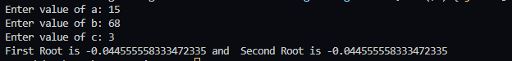

1. **A java program to display the Fibonacci sequence. The program should prompt user for input during run time.**

**DESCRIPTION:**

In mathematics, the Fibonacci numbers or Fibonacci series or Fibonacci sequence are the

numbers in the following integer



By definition, the first two numbers in the Fibonacci sequence are 0 and 1, and each subsequent

number is the sum of the previous two.

In mathematical terms, the sequence

*F*

*n*

of Fibonacci numbers is define

d by the recurrence



With



see



values



Here is a simplest [Java Program t](http://crunchify.com/category/java-web-development-tutorial/)o generate Fibonacci

import java.util.Scanner;

public class FibonacciSeries {

    static int Fibonacci(int numbers){

*if* (numbers == 0){

*return* numbers;

        }

*if* (numbers == 1 || numbers == 2){

*return* 1;

        }

*return* (Fibonacci(numbers-1) + Fibonacci(numbers-2));

    }

    public static void main(String[] args) {

        Scanner input = *new* Scanner(System.in);

        System.out.println("Enter Number. ");

        int number = input.nextInt();

*for* (int i = 0; i < number; i++){

            System.out.print(Fibonacci(i) + " ");

        }

    }

}



1. Write a java program to give example for command line arguments

**DESCRIPTION:**

The java command-line argument is an argument i.e. passed at the time of running the java program. The arguments passed from the console can be received in the java program and it can be used as an input. Command line arguments represent the values passed to main() method. Here, args[] is one dimensional array of String type. So it can store a group of strings, passed to main() from outside by the user i.e, at the time of running the program. The prototype of main( ) when it supports command line arguments is as follows:

**public static void main(String[] args)**

import java.util.Scanner;

public class CommadineArgument {

    public static void main(String[] args) {

        Scanner input = *new* Scanner(System.in);

        System.out.println("Command Line argument is "+args[0]);

    }

}



1. Write a java program to sort given list of numbers ,

**DESCRIPTION:**

The algorithm works by comparing each item in the list with the item next to it, and swapping them if required. In other words, the largest element has bubbled to the top of the array. The algorithm repeats this process until it makes a pass all the way through the list without swapping any items

import java.util.Scanner;

public class BubbleSorting {

    static void Sort(int arr[]){

        int temp;

*for* (int i = 0; i < arr.length; i++) {

*for* (int j = i+1; j < arr.length; j++) {

*if* (arr[i] > arr[j]){

                    temp = arr[i];

                    arr[i] = arr[j];

                    arr[j] = temp;

                }

            }

        }

        System.out.print("Sorted Numbers: ");

*for* (int i *:* arr) {

            System.out.print(i + " ");

        }

    }

    public static void main(String[] args) {

        Scanner input = *new* Scanner(System.in);

        int arr[];

        System.out.print("How many numbers you have? ");

        int len = input.nextInt();

        arr = *new* int[len];

        System.out.print("Enter Numbers: ");

*for* (int i = 0; i < len; i++){

            arr[i] = input.nextInt();

        }

        Sort(arr);

    }

}



1. Write a java program to search for an element in a given list of elements (Linear Search)

**DESCRIPTION:**

Linear search is one of the basic search techniques that we've now. Although this is not a very good search technique, one should understand this concept. Let's consider our aim to search for a key element in an array of elements. We loop through all the array elements and check for existence of the key element. Since we go element by element, this search is called as linear search or sequential search. Search element is called as key element.

import java.util.Scanner;

public class LinearSearch {

    static int Search(int number){

        int arr[] = {1,2,3,45,5,4,6,7,8,9,10};

*for* (int i = 0; i < arr.length; i++) {

*if* (arr[i] == number){

*return* i;

            }

        }

*return* -1;

    }

    public static void main(String[] args) {

        Scanner input = *new* Scanner(System.in);

        System.out.print("Enter the numner you want to search. ");

        int searchingNumber = input.nextInt();

*if* (Search(searchingNumber) == -1){

            System.out.println("Not found.");

        }

*else*{

            System.out.println("Element found at index " + Search(searchingNumber));

        }

    }

}



1. Write a java program to search for an element in a given list of elements (Binary Search)

**DESCRIPTION:**

Generally, to find a value in unsorted array, we should look through elements of an array one by one, until searched value is found. In case of searched value is absent from array, we go through all elements. In average, complexity of such an algorithm is proportional to the length of the array. Situation changes significantly, when array is sorted. If we know it, random access capability can be utilized very efficiently to find searched value quick. Cost of searching algorithm reduces to binary logarithm of the array length. For reference, log 2(1 000 000) ≈ 20. It means, that **in worst case**, algorithm makes 20 steps to find a value in sorted array of a million elements or to say, that it doesn't present it the array.

**Note:** Elements should be in sorted order in the given array

import java.util.Scanner;

public class BinarySearch {

    static int Search(int[] arr, int element, int beg, int end) {

        int mid = (beg + end) / 2;

*if* (beg <= end) {

*if* (element == arr[mid]) {

*return* mid;

            } *else* *if* (element < arr[mid]) {

*return* Search(arr, element, beg, mid - 1);

            } *else* {

*return* Search(arr, element, mid + 1, end);

            }

        } *else* {

*return* - 1;

        }

    }

    public static void main(String[] args) {

        Scanner input = *new* Scanner(System.in);

        int[] arr = {1,2,3,4,5,6,7,8,9,10};

        System.out.print("Enter element. ");

        int element = input.nextInt();

        int index = Search(arr, element, 0, arr.length-1);

*if* (index == -1){

            System.out.println("element not found.");

        } *else* {

            System.out.println("element found on index " + index);

        }

    }

}



1. Write a java program for the following

Example for call by value Example for call by reference.

**DESCRIPTION:**

Java supports call by value by passing a value and returning the value. Call by reference is way of passing object into setter method and returning object as type. Steps to call are:

* 1. Create a object which contains setters and getters.
  2. Use the above object into implementation class and pass Object as a parameter into method and also pass any primitive value into method.
  3. Return the value and Object as return types.

1. public class CallByValueAndReference {
2. private String name;
3. private int id;
4. private CallByValueAndReference obj;
5. public void setName(String name){
6. *this*.name = name;
7. }
8. public void setId(int id){
9. *this*.id = id;
10. }
11. public String getName(){
12. *return* name;
13. }
14. public int getId(){
15. *return* id;
16. }
17. public void setValue(CallByValueAndReference obj){
18. obj.name = "Muhammad Tayyab Bhutto";
19. obj.id = 286;
20. *this*.obj = obj;
21. }
22. public CallByValueAndReference getValue(){
23. *return* obj;
24. }
25. public static void main(String[] args) {
26. CallByValueAndReference obj = *new* CallByValueAndReference();
27. obj.setName("Muhammad Muzammil Bhutto");
28. obj.setId(786);
29. System.out.println("Call By Value. " + obj.getName() +"  "+ obj.getId());
30. obj.setValue(obj);
31. System.out.println("Call By Reference. " + obj.name + "  "+obj.id);
32. }
33. }
34. 

1. Write a java program to demonstrate static variables, methods, and blocks.

**DESCRIPTION:**

Static Keyword in Java is used to access the data without creating Object. Also static creates the single memory allocation for all Objects. Static method can accept only static variables. Static block has height priority than static methods (even there is main) as well as instance methods.

*// Why there is a need of static: it will execute first in program and will destroy when program will end.*

public class StaticBlockVarMeth {

    static int count = 0;

    static int Calculate(int val){

*return* val * count;

    }

    public static void main(String[] args) {

        count = 10;

        System.out.println("Calling Calculate Method in Main Method. " + Calculate(10));

        System.out.println("Value of Static variable in Main after updating. " + count);

    }

    static {

        System.out.println("Hey this static Block And Calling Calculate Method in static block. " + Calculate(9));

    }

}



1. Write a java program to give the example for ‘super’ keyword

**DESCRIPTION:**

Reusability is very important feature in Inheritance, where accessing base class properties and methods is needed. Super keyword is such object which do the job, by handling the super class properties, methods and constructors. Invoking super keyword can be done in following way:

Variable→super.variable_name;

Methods→super.method_name();

Constructor→super(parameter_list);

*// Three usages of super Keyword*

*// Variable having same name in super class and in subclass*

*// Method having same name in super class and in subclass*

*// Calling Constructor*

class SuperClass {

    String name;

    SuperClass(String name){

*this*.name = name;

    }

    void Display(){

        System.out.println("Name " + name);

    }

}

class SubClass extends SuperClass{

    String name;

    SubClass(String name){

*super*(name);    *// Super With Constructor*

        name = *super*.name;  *// Super With Variable Name*

    }

    void Display(){

*super*.Display();

    }

}

public class SuperKeyword {

    public static void main(String[] args) {

        SuperClass superClass = *new* SuperClass("Muhammad Tayyab Bhutto");

        System.out.println("before using super keyword.");

        superClass.Display();

        SubClass subClass = *new* SubClass("Muhammad Muzammil Bhutto");

        System.out.println("after using super keyword.");

        subClass.Display();

    }

}

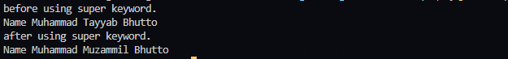

10. Write a java program for multi-level inheritance?

**DESCRIPTION:**

Inheritance is one way of implementing super-sub class relationship, for data usability and readability. Implementing Multi-level inheritance is better one for Objects whose data will be accessed by many objects there by increasing readability.

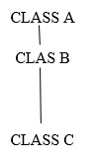

class Animal {

    private String name;

    public void setName(String name){

*this*.name = name;

    }

    public String getName(){

*return* name;

    }

}

class Dog extends Animal {

    private String name;

    public void setName(String name){

*super*.setName(name);

*this*.name = *super*.getName();

    }

    public String getName(){

*return* name;

    }

}

class Cat extends Animal {

    private String name;

    public void setName(String name){

*super*.setName(name);

*this*.name = *super*.getName();

    }

    public String getName(){

*return* name;

    }

}

public class MultiLevelInheritence {

    public static void main(String[] args) {

        Animal animal = *new* Animal();

        Dog dog = *new* Dog();

        Cat cat = *new* Cat();

        animal.setName("Animals");

        dog.setName("Sheru");

        cat.setName("Billy");

        System.out.println(animal.getName());

        System.out.println(dog.getName());

        System.out.println(cat.getName());

    }

}



11. Write a java program to differentiate method overloading and overriding?

**DESCRIPTION:**

Polymorphism is foremost concern in java to implement methods behavior in class and in one or more classes. Having one or forms for the desire of data sharing. Overloading is the one, whose methods have same name but different type signatures. Type promotion is supported in Overloading.

Overriding on the other hand, methods with same name and parameters in more than one class which are of ‘IS-A’ relationship.

*// Overloading and Overriding and two different kinds*

*// Overloading: when two or more methods having same name and different parameters is know as overloading it is compile time pollymorphism*

*// Overriding: when two or more methods having same name and same parameters is know as overriding it is run time pollymorphism*

class Application {

    private String appName;

    private String userName;

    private String password;

*// setData is an overloading method*

    public void setData(String appName){

*this*.appName = appName;

    }

    public void setData(String userName, String password){

*this*.userName = userName;

*this*.password = password;

    }

    public String getAppName(){

*return* appName;

    }

    public String getUsername(){

*return* userName;

    }

    public String getPassword(){

*return* password;

    }

}

class Profile extends Application{

    private String userName;

*// Overriding*

    public void setData(String userName){

*this*.userName = userName;

    }

    public String getUsername(){

*return* userName;

    }

}

public class OvelodingAndOverloading {

    public static void main(String[] args) {

        Application application = *new* Application();

        Profile profile = *new* Profile();

        application.setData("My App");

        application.setData("Muhammad Tayyab Bhutto", "asd123");

        profile.setData("muhammad-tayyab-bhutto");

        System.out.println("App Name: " + application.getAppName() + " \nUser Name: " + application.getUsername());

        System.out.println("Profile id: " + profile.getUsername());

    }

}



12. Java program to differentiate method overloading and constructor overloading.

**DESCRIPTION:**

This program describes the difference between method overloading and constructor loading. Method overloading is a feature that allows a class to have two or more methods having same name, if their argument lists are different. Constructor overloading that allows a class to have more than one constructor having different argument lists. When overload method is called, java looks for a match between the arguments used to call the method and the method parameters. Finally it matches and displays the output.

class Application {

    private String appName;

    private String userName;

    private String password;

*// Constructor overloading*

    Application(){}

    Application(String appName){

*this*.appName = appName;

    }

    Application(String userName, String password){

*this*.userName = userName;

*this*.password = password;

    }

*// setData is an overloading method*

    public void setData(String appName){

*this*.appName = appName;

    }

    public void setData(String userName, String password){

*this*.userName = userName;

*this*.password = password;

    }

    public String getAppName(){

*return* appName;

    }

    public String getUsername(){

*return* userName;

    }

    public String getPassword(){

*return* password;

    }

}

public class MethodAndConstructorOverloading {

    public static void main(String[] args) {

        Application application = *new* Application();

        System.out.println("============================================================================");

        System.out.println("Constructor Overloading");

        Application application1 = *new* Application("CodeSmashers");

        Application application2 = *new* Application("Muhammad Tayyab Bhutto" + "qwe123");

        System.out.println("App Name: " + application1.getAppName() + " \nUser Name: " + application2.getUsername());

        System.out.println("============================================================================");

        System.out.println("Method Overloading");

        application.setData("My App");

        application.setData("Muhammad Tayyab Bhutto", "asd123");

        System.out.println("App Name: " + application.getAppName() + " \nUser Name: " + application.getUsername());

    }

}

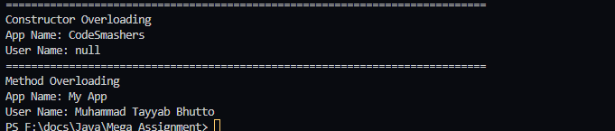

1. Write a JAVA program for example of try and catch block. In this check whether the given array size is negative or not. Also demonstrate the use of finally block.

**DESCRIPTION:**

Program explains exceptions using try and catch block. In the try block array is created. Check the array size is negative or not. If the array size is positive then it will be display array size otherwise it throws an error like java.lang.NegativeArraySizeException.

import java.util.Scanner;

public class TryCatch {

    public static void main(String[] args) {

        Scanner input = *new* Scanner(System.in);

        int number;

        int[] arr;

*try*{

            System.out.print("Enter Size Of Array: ");

            number = input.nextInt();

            arr = *new* int[number];

        } *catch* (NegativeArraySizeException e){

            System.out.println(e);

            System.out.print("Enter Again Size Of Array: ");

            number = input.nextInt();

            arr = *new* int[number];

        }

*finally*{

            System.out.println("finally executed.");

        }

    }

}

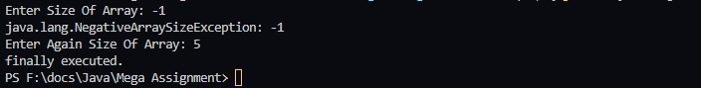

1. Write a JAVA program for creation of user defined exception.

**DESCRIPTION:** If you are creating your own Exception that is known as custom exception or user-defined exception Java custom exceptions are used to customize the exception according to user need.

By the help of custom exception, you can have your own exception and message.

import java.util.Scanner;

class EmployeeIdException extends Exception{

    public EmployeeIdException(String exception){

*super*(exception);

    }

}

class Employee{

    private int id;

    public void setId(int id) throws EmployeeIdException{

*if* (id <= 0 || id > 9999){

*throw* *new* EmployeeIdException("Invalid Employee ID.");

        }

*else* {

*this*.id = id;

        }

    }

    public int getId(){

*return* id;

    }

}

public class UserDefinedExceptions{

    public static void main(String[] args) {

        Scanner input = *new* Scanner(System.in);

        Employee employee = *new* Employee();

        int id;

*try* {

            System.out.print("Enter ID: ");

            id = input.nextInt();

            employee.setId(id);

        } *catch* (EmployeeIdException e) {

            System.out.println(e.getMessage());

*try*{

                System.out.print("Please Enter ID Again: ");

                id = input.nextInt();

                employee.setId(id);

            }

*catch*(EmployeeIdException ex){

                System.out.println(ex.getMessage());

                System.out.println("Thanks your Account is temporary Blocked contact us for more.");

            }

        }

    }

}

1. Write a java program to illustrate multiple inheritance using interfaces?

**DESCRIPTION:** Interfaces are completely abstract classes in Java that provide you with a uniform way to properly delineate the structure or inner workings of your program from its publicly available interface, with the consequence being a greater amount of flexibility and reusable code as well as more control over how you create and interact with other classes. More precisely, they are a special construct in Java with the additional characteristic that allow you to perform a kind of multiple inheritance i.e. classes that can be upcast to more than one class; a technique from which you are severely restricted from undertaking (and with good reason) when working exclusively with classes. To create an interface in Java, you simply use the special interface keyword.

**Note:** Interface consists only abstract methods and static final members.

package Animal;  
  
public abstract class Animal {  
 protected int legs;  
 protected Animal(int legs){  
 this.legs = legs;  
 }  
 public void walk(){  
 System.*out*.println("Animal walks.");  
 }  
 public abstract void eat();  
}

package Animal;  
  
public class Spider extends Animal{  
 protected Spider(){  
 super(8);  
 }  
  
 @Override  
 public void eat() {  
 System.*out*.println("Spider eats insects");  
 }  
}

package Animal;  
  
public interface Pet {  
 public abstract String getName();  
 public abstract void setName(String name);  
 public abstract void play();  
}

package Animal;  
  
public class Cat extends Animal implements Pet{  
 String name;  
 Cat(String name){  
 super(4);  
 this.name = name;  
 }  
 Cat(){  
 this("Cat");  
 }  
 @Override  
 public void eat() {  
 System.*out*.println("Cat eats mice, fish, hens");  
 }  
 @Override  
 public void setName(String name){  
 this.name = name;  
 }  
 @Override  
 public String getName(){  
 return name;  
 }  
 @Override  
 public void play(){  
 System.*out*.println("Cat is playing");  
 }  
  
}

package Animal;  
  
public class Fish extends Animal implements Pet{  
 String name;  
 protected Fish(){  
 super(0);  
 }  
 @Override  
 public void walk(){  
 System.*out*.println("Fish can't walk and don't have legs.");  
 }  
 @Override  
 public void eat(){  
 System.*out*.println("Fish eat feed.");  
 }  
  
 @Override  
 public void play() {  
 System.*out*.println("Fish is playing in water.");  
 }  
  
 @Override  
 public void setName(String name) {  
 this.name = name;  
 }  
  
 @Override  
 public String getName() {  
 return name;  
 }  
  
}

package Animal;  
  
public class Main {  
 public static void main(String[] args) {  
 Fish d = new Fish();  
 Cat c = new Cat("Fluffy");  
 Animal a = new Fish();  
 Animal e = new Spider();  
 Pet p = new Cat();  
 d.eat();  
 d.walk();  
 c.setName("Cat");  
 System.*out*.println(c.getName());  
 c.play();  
 c.eat();  
 a.walk();  
 a.eat();  
 e.eat();  
 e.walk();  
 p.setName("Fish");  
 System.*out*.println(p.getName());  
 p.play();  
 }  
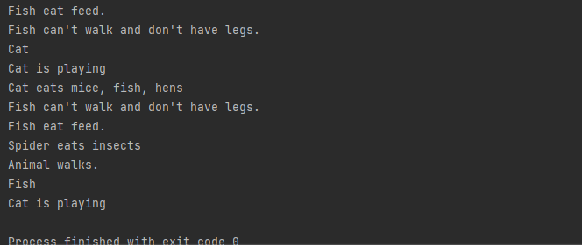}

1. Write a java program to create a package called employee and implement this package out of the package?

**DESCRIPTION:** Packages are used in Java in order to prevent naming conflicts, to control access, to make searching/locating and usage of classes, interfaces, enumerations and annotations easier, etc.

Some of the existing packages in Java are −

* + - * + **java.lang** − bundles the fundamental classes

* + - * + **java.io** − classes for input , output functions are bundled in this package

package Employee;  
public class Employee {  
 private String firstName;  
 private String lastName;  
 private String nationalIdCardNumber;  
 public Employee () {  
 }  
 public Employee(String firstName, String lastName, String nationalIdCardNumber) {  
 this.firstName = firstName;  
 this.lastName = lastName;  
 this.nationalIdCardNumber = nationalIdCardNumber;  
 }  
 void setFirstName(String firstName){  
 this.firstName = firstName;  
 }  
 String getFirstName(){  
 return firstName;  
 }  
 void setLastName(String lastName){  
 this.lastName = lastName;  
 }  
 String getLastName(){  
 return lastName;  
 }  
 void setNationalIdCardNumber(String nationalIdCardNumber){  
 this.nationalIdCardNumber = nationalIdCardNumber;  
 }  
 String getNationalIdCardNumber(){  
 return nationalIdCardNumber;  
 }  
 public String toString() {  
 return firstName+ " " + lastName + " CNIC " + nationalIdCardNumber;  
 }  
 double earnings(){  
 return 0.0;  
 }  
}

//Main

import Employee.*\**;

public class Main {

    public static void main(String[] args) {

        Employee employee = *new* Employee("Muhammad" , "Tayyab Bhutto", "023-21-0286");

        System.out.println(employee.toString());

    }

}

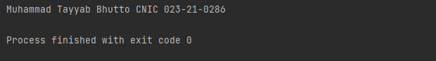

1. Write a JAVA program to create a dialog box and menu.

**DESCRIPTION:**

Dialog control represents a top-level window with a title and a border used to take some form of input from the user. This class inherits methods from the following classes:

* + - * + java.awt.Window

* + - * + java.awt.Component

* + - * + java.lang.Object

package: **java.awt.Dialog**

**output**

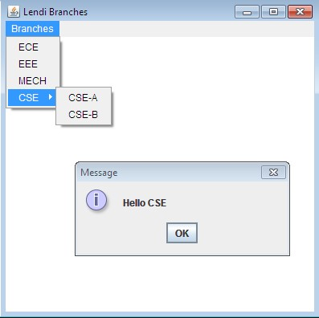

import java.awt.event.*\**;

import java.awt.*\**;

import javax.swing.*\**;

public class DialogBoxAndMenu extends JFrame {

    JFrame jFrame;

    JMenu menu, submenu;

    JMenuItem item1, item2, item3, item4, item5;

    public DialogBoxAndMenu(){

        jFrame = *new* JFrame("Lendi Braches.");

        JMenuBar jmenubar = *new* JMenuBar();

        menu = *new* JMenu("Branches");

        submenu = *new* JMenu("CSE");

        item1 = *new* JMenuItem("ECE");

        item2 = *new* JMenuItem("EEE");

        item3 = *new* JMenuItem("MECH");

        item4 = *new* JMenuItem("CSE-A");

        item5 = *new* JMenuItem("CSE-B");

        menu.add(item1);

        menu.add(item2);

        menu.add(item3);

        submenu.add(item4);

        submenu.add(item5);

        menu.add(submenu);

        jmenubar.add(menu);

        item1.addActionListener(*new* ActionListener() {

            @Override

            public void actionPerformed(ActionEvent e) {

                JFrame jFrame1 = *new* JFrame("Message");

                JLabel label = *new* JLabel();

                JButton ece = *new* JButton("OK");

                ece.setSize(50,50);

                label.setText("Hello ECE");

                jFrame1.add(label, BorderLayout.NORTH);

                jFrame1.add(ece, BorderLayout.SOUTH);

                jFrame1.setSize(400,200);

                jFrame1.setDefaultCloseOperation(EXIT_ON_CLOSE);

                jFrame1.setVisible(true);

            }

        });

        item2.addActionListener(*new* ActionListener() {

            @Override

            public void actionPerformed(ActionEvent e) {

                JFrame jFrame1 = *new* JFrame("Message");

                JLabel label = *new* JLabel();

                JButton ece = *new* JButton("OK");

                ece.setSize(50,50);

                label.setText("Hello EEE");

                jFrame1.add(label, BorderLayout.NORTH);

                jFrame1.add(ece, BorderLayout.SOUTH);

                jFrame1.setSize(400,200);

                jFrame1.setDefaultCloseOperation(EXIT_ON_CLOSE);

                jFrame1.setVisible(true);

            }

        });

        item3.addActionListener(*new* ActionListener() {

            @Override

            public void actionPerformed(ActionEvent e) {

                JFrame jFrame1 = *new* JFrame("Message");

                JLabel label = *new* JLabel();

                JButton ece = *new* JButton("OK");

                ece.setSize(50,50);

                label.setText("Hello MECH");

                jFrame1.add(label, BorderLayout.NORTH);

                jFrame1.add(ece, BorderLayout.SOUTH);

                jFrame1.setSize(400,200);

                jFrame1.setDefaultCloseOperation(EXIT_ON_CLOSE);

                jFrame1.setVisible(true);

            }

        });

        item4.addActionListener(*new* ActionListener() {

            @Override

            public void actionPerformed(ActionEvent e) {

                JFrame jFrame1 = *new* JFrame("Message");

                JLabel label = *new* JLabel();

                JButton ece = *new* JButton("OK");

                ece.setSize(50,50);

                label.setText("Hello CSE-A");

                jFrame1.add(label, BorderLayout.NORTH);

                jFrame1.add(ece, BorderLayout.SOUTH);

                jFrame1.setSize(400,200);

                jFrame1.setDefaultCloseOperation(EXIT_ON_CLOSE);

                jFrame1.setVisible(true);

            }

        });

        item5.addActionListener(*new* ActionListener() {

            @Override

            public void actionPerformed(ActionEvent e) {

                JFrame jFrame1 = *new* JFrame("Message");

                JLabel label = *new* JLabel();

                JButton ece = *new* JButton("OK");

                ece.setSize(50,50);

                label.setText("Hello CSE-B");

                jFrame1.add(label, BorderLayout.NORTH);

                jFrame1.add(ece, BorderLayout.SOUTH);

                jFrame1.setSize(400,200);

                jFrame1.setDefaultCloseOperation(EXIT_ON_CLOSE);

                jFrame1.setVisible(true);

            }

        });

        jFrame.setJMenuBar(jmenubar);

        jFrame.setSize(400,400);

        jFrame.setLayout(null);

        jFrame.setDefaultCloseOperation(EXIT_ON_CLOSE);

        jFrame.setVisible(true);

    }

    public static void main(String[] args) {

        DialogBoxAndMenu dialogBoxAndMenu = *new* DialogBoxAndMenu();

    }

}

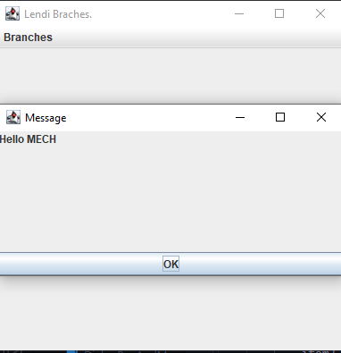

1. Write a java program to create a simple calculator.

**DESCRIPTION:**

This program is used to create a simple calculator having basic arithmetic operations like addition, subtraction, multiplication, division and modulo division. This calculator is having buttons and these buttons are created using Button() method. Also this having text field to display result.

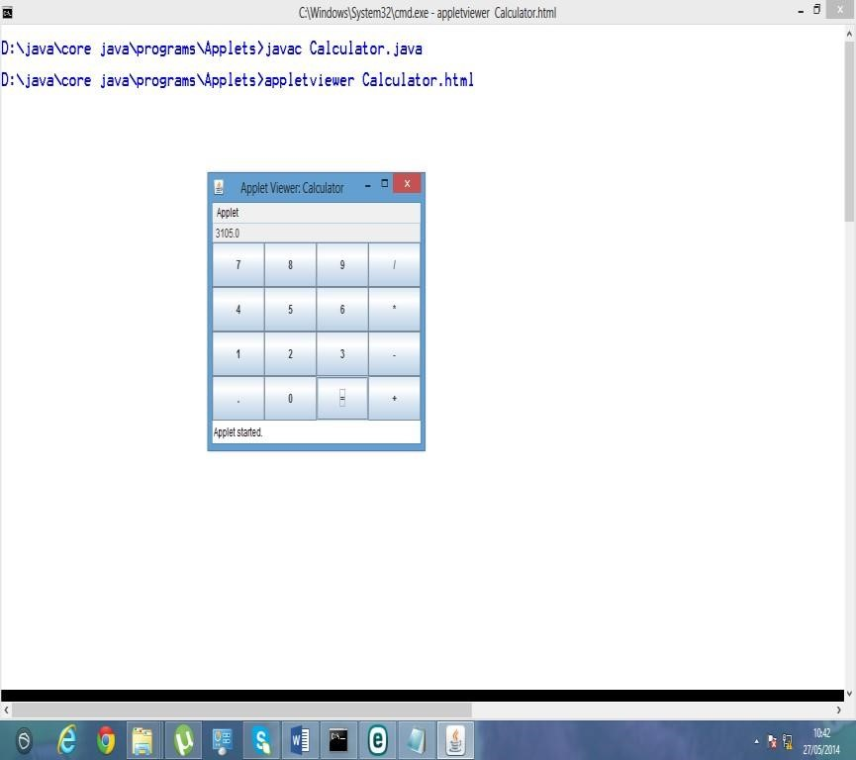

import java.awt.*\**;

import java.awt.event.ActionEvent;

import java.awt.event.ActionListener;

import javax.swing.*\**;

import java.awt.event.KeyAdapter;

import java.awt.event.KeyEvent;

import java.util.*\**;

import java.util.List;

class solveExpression {

    private String exp;

    protected int returnType = 0; */* 0, 1, 2 */*

    protected String ans[] = {"Syntax Error !", "Math Error !", ""};

    private StringTokenizer element;

    private List<String> infix, prefix;

    protected solveExpression(String exp) {

*this*.exp = exp;

*if* (!error()) {

            infixToPrefix();

            calculatePrefix();

        }

    }

    protected String Answer() {

*return* ans[returnType];

    }

    private boolean error() {

        element = *new* StringTokenizer(exp, "+-x/()*", true);

        infix = *new* ArrayList<String>();

*while* (element.hasMoreElements())

            infix.add(*new* String(element.nextElement().toString()));

*for* (int i = 0; i < infix.size(); i++) {

            String s = infix.get(i);

*if* (s.equals("+") || s.equals("-") || s.equals("(")) {

*if* (i == infix.size()-1) *return* true;

                String t = infix.get(i+1);

*if* (t.equals("x") || t.equals("/") || t.equals(")")) *return* true;

*if* (s.equals("+") || s.equals("-")) {

*if* (t.equals("+")) {

                        infix.remove(i+1);

                        i--;

                    }

*else* *if* (t.equals("-")) {

                        infix.set(i, s.equals("+") *?* "-" *:* "+");

                        infix.remove(i+1);

                        i--;

                    }

*else* {

*if* (i == 0) {infix.add(i--, "0"); *continue*;}

                        String g = infix.get(i-1);

*if* (t.equals("(")) {

*if* (g.equals("x") || g.equals("/")) {

                                infix.set(i, s.equals("+") *?* "1" *:* "-1");

                                infix.add(i+1, g);

                                i--;

                            }

*else* *if* (g.equals("(")) {

*if* (s.equals("+")) infix.remove(i--);

*else* infix.add(i--, "0");

                            }

*continue*;

                        }

*if* (g.equals("(") || g.equals("x") || g.equals("/")) {

*if* (s.equals("+")) infix.remove(i--);

*else* {

                                infix.remove(i);

                                StringBuilder num = *new* StringBuilder("-");

                                num.append(infix.get(i));

                                infix.set(i, *new* String(num));

                                i--;

                            }

                        }

                    }

                }

            }

*else* *if* (s.equals("x") || s.equals("/")) {

*if* (i == 0 || i == infix.size()-1) *return* true;

                String t = infix.get(i+1);

*if* (t.equals("x") || t.equals("/") || t.equals(")")) *return* true;

            }

*else* *if* (s.equals(")")) {

*if* (i == 0) *return* true;

*if* (i == infix.size()-1) *continue*;

                String t = infix.get(i+1);

*if* (t.equals("+") || t.equals("-") || t.equals("x") || t.equals("/") || t.equals(")")) *continue*;

*if* (t.equals("(")) {

                    infix.add(i+1, "x"); *continue*;

                }

*return* true;

            }

*else* {

*try* {

                    double t = (double) Double.parseDouble(s);

                }

*catch* (NumberFormatException e) {

*return* true;

                }

*if* (i == infix.size()-1) *continue*;

                String t = infix.get(i+1);

*if* (t.equals("(")) infix.add(i+1, "x");

            }

        }

*return* checkOpenClose();

    }

    private boolean checkOpenClose() {

        int cnt = 0;

*for* (String s *:* infix) {

*if* (s.equals("(")) cnt++;

*else* *if* (s.equals(")")) {

*if* (cnt == 0) *return* true;

                cnt--;

            }

        }

*for* (; cnt > 0; cnt--) infix.add(")");

*return* cnt == 0 *?* false *:* true;

    }

    private int rank(String s) {

*if* (s.equals("x") || s.equals("/")) *return* 2;

*if* (s.equals("+") || s.equals("-")) *return* 1;

*return* 0;

    }

    private void infixToPrefix() {

        Collections.reverse(infix);

        Deque<String> st = *new* LinkedList<String>();

        prefix = *new* ArrayList<String>();

*for* (String t *:* infix) {

*if* (t.equals("+") || t.equals("-") || t.equals("x") || t.equals("/")) {

*while* (!st.isEmpty() && rank(st.peek()) > rank(t)) {

                    prefix.add(st.pop());

                }

                st.push(t);

            }

*else* *if* (t.equals(")")) {

                st.push(t);

            }

*else* *if* (t.equals("(")) {

*while* (!st.isEmpty() && !st.peek().equals(")")) {

                    prefix.add(st.pop());

                }

                st.pop();

            }

*else* {

                prefix.add(t);

            }

        }

*while* (!st.isEmpty()) prefix.add(st.pop());

        Collections.reverse(prefix);

    }

    private void calculatePrefix() {

        Collections.reverse(prefix);

        Deque<Double> st = *new* LinkedList<Double>();

*for* (String t *:* prefix) {

*if* (t.equals("+") || t.equals("-") || t.equals("x") || t.equals("/")) {

                double a = st.pop(), b = st.pop();

*if* (t.equals("+")) a += b;

*else* *if* (t.equals("-")) a -= b;

*else* *if* (t.equals("x")) a *= b;

*else* {

*if* (Math.abs(b) <= Double.MIN_NORMAL) {

                        returnType = 1;

*return* ;

                    }

                    a /= b;

                }

                st.push(a);

            }

*else* {

                st.push(Double.parseDouble(t));

            }

        }

        returnType = 2;

        ans[2] = st.pop().toString();

    }

}

public class SimpleCalculator extends JFrame {

    public SimpleCalculator() {

*this*.initComponent();

*this*.pack();

*this*.setLocationRelativeTo(null);

*this*.setVisible(true);

    }

    private void initComponent() {

        labelCalculator = *new* JLabel();

        ScreenUserInterface = *new* JPanel();

        screenInput = *new* JTextField();

        screenOutput = *new* JTextField();

        ButtonUserInterface = *new* JPanel();

        copyright = *new* JLabel();

        setDefaultCloseOperation(javax.swing.WindowConstants.EXIT_ON_CLOSE);

        setAutoRequestFocus(false);

        setBackground(*new* java.awt.Color(255, 255, 255));

        setPreferredSize(*new* java.awt.Dimension(500, 600));

        setResizable(false);

        getContentPane().setLayout(*new* java.awt.FlowLayout(java.awt.FlowLayout.CENTER, 0, 10));

        setTitle("Calculator - Using Java Swing ");

        setFocusTraversalKeysEnabled(false);

        labelCalculator.setBackground(*new* Color(0, 0, 0));

        labelCalculator.setFont(*new* Font("Verdana", 1, 30));

        labelCalculator.setForeground(*new* Color(0, 255, 51));

        labelCalculator.setHorizontalAlignment(SwingConstants.CENTER);

        labelCalculator.setText("CALCULATOR");

        labelCalculator.setOpaque(true);

        labelCalculator.setPreferredSize(*new* Dimension(480, 50));

        getContentPane().add(labelCalculator);

        ScreenUserInterface.setPreferredSize(*new* java.awt.Dimension(450, 150));

        ScreenUserInterface.setLayout(*new* java.awt.GridLayout(2, 0, 0, 20));

        screenInput.setFont(*new* java.awt.Font("Courier New", Font.BOLD, 30));

        screenInput.setHorizontalAlignment(javax.swing.JTextField.LEFT);

        screenInput.setBorder(*new* javax.swing.border.LineBorder(*new* java.awt.Color(102, 102, 102), 3, true));

        screenInput.setSelectedTextColor(Color.WHITE);

        screenInput.setSelectionColor(Color.DARK_GRAY);

        addScreenInputEvent();

        screenOutput.setEditable(false);

        screenOutput.setFont(*new* java.awt.Font("Courier New", Font.BOLD, 30));

        screenOutput.setForeground(*new* java.awt.Color(0, 51, 204));

        screenOutput.setOpaque(true);

        screenOutput.setBackground(Color.WHITE);

        screenOutput.setHorizontalAlignment(javax.swing.JTextField.RIGHT);

        screenOutput.setBorder(*new* javax.swing.border.LineBorder(*new* java.awt.Color(102, 102, 102), 3, true));

        screenOutput.setSelectedTextColor(Color.WHITE);

        screenOutput.setSelectionColor(Color.DARK_GRAY);

        ScreenUserInterface.add(screenInput);

        ScreenUserInterface.add(screenOutput);

        getContentPane().add(ScreenUserInterface);

        ButtonUserInterface.setPreferredSize(*new* java.awt.Dimension(420, 270));

        ButtonUserInterface.setLayout(*new* java.awt.GridLayout(0, 5, 10, 10));

*for* (int i = 0; i < stringButton.length; i++) {

            b[i] = *new* JButton(stringButton[i]);

            b[i].setFont(*new* java.awt.Font("Verdana", 1, 25));

            b[i].setMargin(*new* java.awt.Insets(0, 0, 0, 0));

            b[i].setForeground(Color.black);

        }

        b[10].setForeground(*new* Color(0,50,162));

        b[11].setForeground(*new* Color(0,50,162));

        b[12].setForeground(*new* Color(0,50,162));

        b[19].setForeground(*new* Color(200, 0, 0));

*for*(int i=13;i<=16;i++) b[i].setForeground(*new* Color(200, 0, 0));

        b[17].setForeground(Color.red);

        b[18].setForeground(Color.red);

        b[10].setFont(*new* java.awt.Font("Verdana", 1, 35));

        b[13].setFont(*new* java.awt.Font("Verdana", 1, 30));

        b[14].setFont(*new* java.awt.Font("Verdana", 1, 40));

        b[15].setFont(*new* java.awt.Font("Verdana", 1, 30));

        b[19].setFont(*new* java.awt.Font("Verdana", 1, 30));

        addButtonEvent();

*for* (int i = 0; i < stringButton.length; i++) ButtonUserInterface.add(b[orderButtonDisplay[i]]);

        getContentPane().add(ButtonUserInterface);

        copyright.setBackground(*new* Color(0, 0, 0));

        copyright.setFont(*new* Font("Verdana", 1, 23));

        copyright.setForeground(*new* Color(0, 255, 0));

        copyright.setHorizontalAlignment(SwingConstants.CENTER);

        copyright.setText("Muhammad Tayyab Bhutto");

        copyright.setOpaque(true);

        copyright.setPreferredSize(*new* Dimension(480, 50));

        getContentPane().add(copyright);

    }

    private void updateScreenInput(String add) {

        StringBuilder cur = *new* StringBuilder(screenInput.getText());

        int pos = screenInput.getCaretPosition();

        cur.insert(pos, add);

        screenInput.setText(*new* String(cur));

        screenInput.setCaretPosition(pos+add.length());

    }

    private void addScreenInputEvent() {

        screenInput.addKeyListener(*new* KeyAdapter() {

            @Override

            public void keyTyped(KeyEvent e) {

                e.consume();

                char c = e.getKeyChar();

                String sc = Character.toString(c);

*for* (int i = 0; i < 17; i++) {

*if* (sc.equals(stringButton[i])) {

                        updateScreenInput(sc); *break*;

                    }

                }

*if* (c == '*') updateScreenInput("x");

*if* (c == '=' || c == KeyEvent.VK_ENTER) {

                    String exp = screenInput.getText();

                    screenOutput.setText(*new* solveExpression(exp).Answer());

                }

            }

        });

    }

    private void addButtonEvent() {

*for* (int i = 0; i <= 16; i++) {

            String g = stringButton[i];

            b[i].addActionListener(*new* ActionListener() {

                @Override

                public void actionPerformed(ActionEvent e) {

                    updateScreenInput(g);

                }

            });

        }

        b[17].addActionListener(*new* ActionListener() {

            @Override

            public void actionPerformed(ActionEvent e) {

                screenInput.setText("");

                screenOutput.setText("");

            }

        });

        b[18].addActionListener(*new* ActionListener() {

            @Override

            public void actionPerformed(ActionEvent e) {

                String s = screenInput.getText();

*if* (s.length() == 0) *return* ;

                int pos = screenInput.getCaretPosition();

*if* (pos == 0) *return* ;

                String t = s.substring(0, pos-1);

                screenInput.setText(t.concat(s.substring(pos, s.length())));

                screenInput.setCaretPosition(pos-1);

            }

        });

        b[19].addActionListener(*new* ActionListener() {

            @Override

            public void actionPerformed(ActionEvent e) {

                String exp = screenInput.getText();

                screenOutput.setText(*new* solveExpression(exp).Answer());

            }

        });

    }

*/* Variables declaration*/*

    private javax.swing.JPanel ButtonUserInterface;

    private javax.swing.JPanel ScreenUserInterface;

    private javax.swing.JLabel labelCalculator;

    private javax.swing.JLabel copyright;

    private javax.swing.JTextField screenInput;

    private javax.swing.JTextField screenOutput;

    private String stringButton[] = {"0","1","2","3","4","5","6","7","8","9",

                                    ".","(",")","+","-","x","/","AC","DEL","="};

    private JButton b[] = *new* JButton[stringButton.length];

    private int orderButtonDisplay[] = {

        7,  8,  9,  18, 17,

        4,  5,  6,  15, 16,

        1,  2,  3,  13, 14,

        0,  10, 19, 11, 12,

    };

    public static void main(String[] args) {

*new* SimpleCalculator();

    }

}

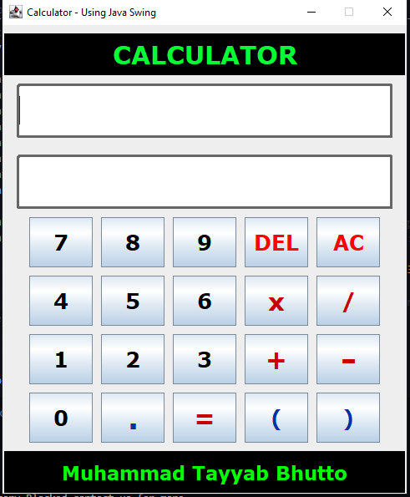

1. Basic tasks for classes

Download the recommended textbook named “Java: How to Program by Deital and Deital”. Go to page 441 and write the codes for the following exercises

8.3 8.8 8.9 8.15

Static

8.16 8.17

abstract class Employee {

    private String firstName;

    private String lastName;

    private String socialSecurityNumber;

*// three-argument constructor*

    public Employee(String first, String last, String ssn) {

        firstName = first;

        lastName = last;

        socialSecurityNumber = ssn;

    } *// end three-argument Employee constructor*

*// set first name*

    public void setFirstName(String first) {

        firstName = first; *// should validate*

    } *// end method setFirstName*

*// return first name*

    public String getFirstName() {

*return* firstName;

    } *// end method getFirstName*

*// set last name*

    public void setLastName(String last) {

        lastName = last; *// should validate*

    } *// end method setLastName*

*// return last name*

    public String getLastName() {

*return* lastName;

    } *// end method getLastName*

*// set social security number*

    public void setSocialSecurityNumber(String ssn) {

        socialSecurityNumber = ssn; *// should validate*

    } *// end method setSocialSecurityNumber*

*// return social security number*

    public String getSocialSecurityNumber() {

*return* socialSecurityNumber;

    } *// end method getSocialSecurityNumber*

*// return String representation of Employee object*

    @Override

    public String toString() {

*return* String.format("%s %s\nsocial security number: %s", getFirstName(), getLastName(), getSocialSecurityNumber());

    } *// end method toString*

*// abstract method overridden by concrete subclasses*

    public abstract double earnings(); *// no implementation here*

} *// end abstract class Employee*

class SalariedEmployee extends Employee {

    private double weeklySalary;

    double baseSalary;

*// four-argument constructor*

    public SalariedEmployee(String first, String last, String ssn, double salary) {

*super*(first, last, ssn); *// pass to Employee constructor*

        setWeeklySalary(salary); *// validate and store salary*

    } *// end four-argument SalariedEmployee constructor*

*// set salary*

    public void setWeeklySalary(double salary) {

*if* (salary >= 0.0) {

            baseSalary = salary;

        } *else* {

*throw* *new* IllegalArgumentException("Weekly salary must be");

        }

    }

*// calculate earnings; override abstract method earnings in Employee*

*// return salary*

    public double getWeeklySalary() {

*return* weeklySalary;

    } *// end method getWeeklySalary*

    @Override

    public double earnings() {

*return* getWeeklySalary();

    } *// end method earnings*

*// return String representation of SalariedEmployee object*

    @Override

    public String toString() {

*return* String.format("salaried employee: %s\n%s: $%,.2f",

*super*.toString(), "weekly salary", getWeeklySalary());

    } *// end method toString*

} *// end class SalariedEmployee*

class HourlyEmployee extends Employee {

    private double wage; *// wage per hour*

    private double hours; *// hours worked for week*

*// five-argument constructor*

    public HourlyEmployee(String first, String last, String ssn,

            double hourlyWage, double hoursWorked) {

*super*(first, last, ssn);

        setWage(hourlyWage); *// validate hourly wage*

        setHours(hoursWorked); *// validate hours worked*

    } *// end five-argument HourlyEmployee constructor*

*// set wage*

    public void setWage(double hourlyWage) {

*if* (hourlyWage >= 0.0) {

            wage = hourlyWage;

        } *else* {

*throw* *new* IllegalArgumentException("Hourly wage must be >= 0.0");

        }

    } *// end method setWage*

*// return wage*

    public double getWage() {

*return* wage;

    } *// end method getWage*

*// set hours worked*

    public void setHours(double hoursWorked) {

*if* ((hoursWorked >= 0.0) && (hoursWorked <= 168.0)) {

            hours = hoursWorked;

        } *else* {

*throw* *new* IllegalArgumentException("Hours worked must be >= 0.0 and <= 168.0");

        }

    } *// end method setHours*

*// return hours worked*

    public double getHours() {

*return* hours;

    } *// end method getHours*

*// calculate earnings; override abstract method earnings in Employee*

    @Override

    public double earnings() {

*if* (getHours() <= 40) *// no overtime*

        {

*return* getWage() * getHours();

        } *else* {

*return* 40 * getWage() + (getHours() - 40) * getWage() * 1.5;

        }

    } *// end method earnings*

*// return String representation of HourlyEmployee object*

    @Override

    public String toString() {

*return* String.format("hourly employee: %s\n%s: $%,.2f; %s: %,.2f",

*super*.toString(), "hourly wage", getWage(),

                "hours worked", getHours());

    } *// end method toString*

}*// end class HourlyEmployee*

class CommissionEmployee extends Employee {

    private double grossSales; *// gross weekly sales*

    private double commissionRate; *// commission percentage*

*// five-argument constructor*

    public CommissionEmployee(String first, String last, String ssn,

            double sales, double rate) {

*super*(first, last, ssn);

        setGrossSales(sales);

        setCommissionRate(rate);

    } *// end five-argument CommissionEmployee constructor*

*// set commission rate*

    public void setCommissionRate(double rate) {

*if* (rate > 0.0 && rate < 1.0) {

            commissionRate = rate;

        } *else* {

*throw* *new* IllegalArgumentException("Commission rate must be > 0.0 and < 1.0");

        }

    } *// end method setCommissionRate*

*// return commission rate*

    public double getCommissionRate() {

*return* commissionRate;

    } *// end method getCommissionRate*

*// set gross sales amount*

    public void setGrossSales(double sales) {

*if* (sales >= 0.0) {

            grossSales = sales;

        } *else* {

*throw* *new* IllegalArgumentException("Gross sales must be >= 0.0");

        }

    } *// end method setGrossSales*

*// return gross sales amount*

    public double getGrossSales() {

*return* grossSales;

    } *// end method getGrossSales*

*// calculate earnings; override abstract method earnings in Employee*

    @Override

    public double earnings() {

*return* getCommissionRate() * getGrossSales();

    } *// end method earnings*

*// return String representation of CommissionEmployee object*

    @Override

    public String toString() {

*return* String.format("%s: %s\n%s: $%,.2f; %s: %.2f", "commission employee", *super*.toString(), "gross sales",

                getGrossSales(), "commission rate", getCommissionRate());

    } *// end method toString*

} *// end class CommissionEmployee*

class BasePlusCommissionEmployee extends CommissionEmployee {

    private double baseSalary; *// base salary per week*

*// six-argument constructor*

    public BasePlusCommissionEmployee(String first, String last,

            String ssn, double sales, double rate, double salary) {

*super*(first, last, ssn, sales, rate);

        setBaseSalary(salary); *// validate and store base salary*

    } *// end six-argument BasePlusCommissionEmployee constructor*

*// set base salary*

    public void setBaseSalary(double salary) {

*if* (salary >= 0.0) {

            baseSalary = salary;

        } *else* {

*throw* *new* IllegalArgumentException("Base salary must be >= 0.0");

        }

    } *// end method setBaseSalary*

*// return base salary*

    public double getBaseSalary() {

*return* baseSalary;

    } *// end method getBaseSalary*

*// calculate earnings; override method earnings in CommissionEmployee*

    @Override

    public double earnings() {

*return* getBaseSalary() + *super*.earnings();

    } *// end method earnings*

*// return String representation of BasePlusCommissionEmployee object*

    @Override

    public String toString() {

*return* String.format("%s %s; %s: $%,.2f", "base-salaried", *super*.toString(), "base salary", getBaseSalary());

    } *// end method toString*

} *// end class BasePlusCommissionEmployee*

public class PayrollSystemTest {

    public static void main(String[] args) {

*// create subclass objects*

        SalariedEmployee salariedEmployee = *new* SalariedEmployee("Muhammad Tayyab", "Bhutto", "111-11-1111", 800.00);

        HourlyEmployee hourlyEmployee = *new* HourlyEmployee("Tanveer", "Ahmed", "222-22-2222", 16.75, 40);

        CommissionEmployee commissionEmployee = *new* CommissionEmployee(

                "Muhammad", "Muzammil", "333-33-3333", 10000, .06);

        BasePlusCommissionEmployee basePlusCommissionEmployee = *new* BasePlusCommissionEmployee(

                "Amjad", "Umar", "444-44-4444", 5000, .04, 300);

        System.out.println("Employees processed individually:\n");

        System.out.printf("%s\n%s: $%,.2f\n\n",

                salariedEmployee, "earned", salariedEmployee.earnings());

        System.out.printf("%s\n%s: $%,.2f\n\n",

                hourlyEmployee, "earned", hourlyEmployee.earnings());

        System.out.printf("%s\n%s: $%,.2f\n\n",

                commissionEmployee, "earned", commissionEmployee.earnings());

        System.out.printf("%s\n%s: $%,.2f\n\n",

                basePlusCommissionEmployee, "earned", basePlusCommissionEmployee.earnings());

*// create four-element Employee array*

        Employee[] employees = *new* Employee[4];

*// initialize array with Employees*

        employees[0] = salariedEmployee;

        employees[1] = hourlyEmployee;

        employees[2] = commissionEmployee;

        employees[3] = basePlusCommissionEmployee;

        System.out.println("Employees processed polymorphically:\n");

*// generically process each element in array employees*

*for* (Employee currentEmployee *:* employees) {

            System.out.println(); *// invokes toString*

*// determine whether element is a BasePlusCommissionEmployee*

*if* (currentEmployee instanceof BasePlusCommissionEmployee) {

*// downcast Employee reference to*

*// BasePlusCommissionEmployee reference*

                BasePlusCommissionEmployee employee = (BasePlusCommissionEmployee) currentEmployee;

                employee.setBaseSalary(1.10 * employee.getBaseSalary());

                System.out.printf("new base salary with 10%% increase is: $%,.2f\n", employee.getBaseSalary());

            } *// end if*

            System.out.printf("earned $%,.2f\n\n", currentEmployee.earnings());

        } *// end for*

*// get type name of each object in employees array*

*for* (int j = 0; j < employees.length; j++) {

            System.out.printf("Employee %d is a %s\n", j, employees[j].getClass().getName());

        }

    }

}

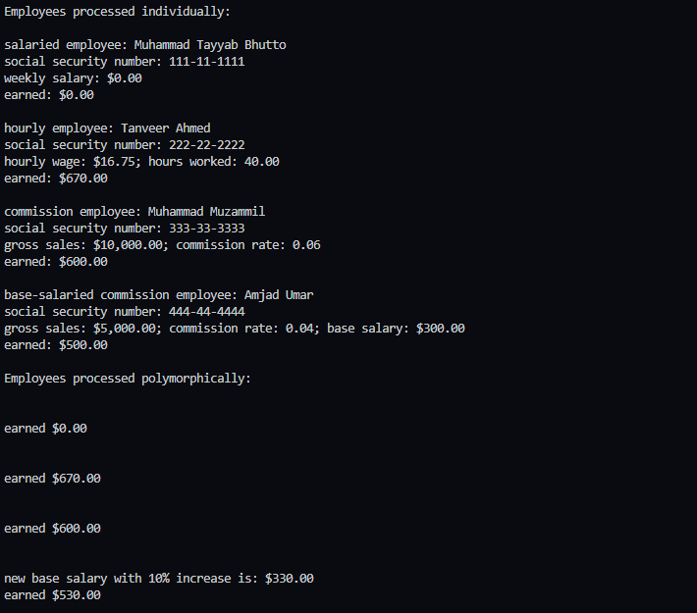

1. Inheritance exercises

**1. A Bank**

Look at the Account class [Account.java](https://www.cs.bham.ac.uk/~mdr/teaching/RedHotChilli/java/Account.java) and write a main method in a different class to briefly experiment with some instances of the Account class.

* + - * Using the Account class as a base class, write two derived classes

called SavingsAccount and CurrentAccount. A SavingsAccount object, in addition to the attributes of an Account object, should have an interest variable and a method which adds interest to the account. A CurrentAccount object, in addition to the attributes of an Account object, should have an overdraft limit variable. Ensure that you have overridden methods of the Account class as necessary in both derived classes. o Now create a Bank class, an object of which contains an array of Account objects. Accounts in the array could be instances of

the Account class, the SavingsAccount class, or the CurrentAccount class. Create some test accounts (some of each type). o Write an update method in the bank class. It iterates through each account, updating it in the following ways: Savings accounts get interest added (via the method you already wrote); CurrentAccounts get a letter sent if they are in overdraft.

* + - * The Bank class requires methods for opening and closing accounts, and for paying a dividend into each account.

**Hints:** o Note that the balance of an account may only be modified through the deposit(double) and withdraw(double) methods.

* + - * The Account class should not need to be modified at all.
      * Be sure to test what you have done after each step.
* class Account {
* private int accountNumber; *// account number*
* private int pin; *// PIN for authentication*
* private double availableBalance; *// funds available for withdrawal*
* private double totalBalance; *// funds available + pending deposits*
* *// Account constructor initializes attributes*
* public Account(int theAccountNumber, int thePIN, double theAvailableBalance, double theTotalBalance) {
* accountNumber = theAccountNumber;
* pin = thePIN;
* availableBalance = theAvailableBalance;
* totalBalance = theTotalBalance;
* } *// end Account constructor*
* *// determines whether a user-specified PIN matches PIN in Account*
* public boolean validatePIN(int userPIN) {
* *if* (userPIN == pin)
* *return* true;
* *else*
* *return* false;
* } *// end method validatePIN*
* *// returns available balance*
* public double getAvailableBalance() {
* *return* availableBalance;
* } *// end getAvailableBalance*
* *// returns the total balance*
* public void setTotalBalance(double totalBalance) {
* *this*.totalBalance = totalBalance;
* }
* public double getTotalBalance() {
* *return* totalBalance;
* } *// end method getTotalBalance*
* *// credits an amount to the account*
* public void credit(double amount) {
* totalBalance += amount; *// add to total balance*
* } *// end method credit*
* *// debits an amount from the account*
* public void debit(double amount) {
* availableBalance -= amount; *// subtract from available balance*
* totalBalance -= amount; *// subtract from total balance*
* } *// end method debit*
* *// returns account number*
* public int getAccountNumber() {
* *return* accountNumber;
* } *// end method getAccountNumber*
* public String toString(){
* *return* "Account Number: " + accountNumber + " Availble Balance: " + availableBalance + " Total Balance: " + totalBalance;
* }
* } *// end class Account*
* class SavingsAccount extends Account {
* private double interest;
* private int year;
* public SavingsAccount(int theAccountNumber, int thePIN, double theAvailableBalance, double theTotalBalance, int year){
* *super*(theAccountNumber, thePIN, theAvailableBalance, theTotalBalance);
* *this*.year = year;
* }
* public void getInterest(){
* double principal = 1000.0; *// initial amount before interest*
* double rate = 0.05; *// interest rate*
* *// calculate amount on deposit for each of ten years*
* *// calculate new amount for specified year*
* interest = principal * Math.pow( 1.0 + rate, year );
* *// display the year and the amount*
* System.out.println( "Year: "+ year+ " Interest: "+ interest);
* }
* public String toString(){
* *return* *super*.toString() + " Interest: " + interest + " Years: " + year;
* }
* }
* class CurrentAccount extends Account {
* private double newAmount;
* public CurrentAccount(int theAccountNumber, int thePIN, double theAvailableBalance, double theTotalBalance, double newAmount) {
* *super*(theAccountNumber, thePIN, theAvailableBalance, theTotalBalance);
* *this*.newAmount = newAmount;
* }
* public void setNewAmount(double newAmount){
* *this*.newAmount = newAmount;
* }
* public void getOverDraft(){
* *if* (newAmount > 100000){
* System.out.println("Overdraft");
* } *else* {
* setTotalBalance(newAmount+getTotalBalance());
* System.out.println("Added To Your Balance. " + getTotalBalance());
* }
* }
* public String toString(){
* *return* *super*.toString() + " Current Amount: " + newAmount;
* }
* }
* class Bank {
* private Account[] accounts; *// array of Accounts*
* public Bank() {
* accounts = *new* Account[2]; *// just 2 accounts for testing*
* accounts[0] = *new* Account(12345, 54321, 1000.0, 12000);
* accounts[1] = *new* Account(98765, 56789, 200.0, 200.0);
* } *// end no-argument BankDatabase constructor*
* *// retrieve Account object containing specified account number*
* private Account getAccount(int accountNumber) {
* *// loop through accounts searching for matching account number*
* *for* (Account currentAccount *:* accounts) {
* *// return current account if match found*
* *if* (currentAccount.getAccountNumber() == accountNumber)
* *return* currentAccount;
* } *// end for*
* *return* null; *// if no matching account was found, return null*
* } *// end method getAccount*
* *// determine whether user-specified account number and PIN match*
* *// those of an account in the database*
* public boolean authenticateUser(int userAccountNumber, int userPIN) {
* *// attempt to retrieve the account with the account number*
* Account userAccount = getAccount(userAccountNumber);
* *// if account exists, return result of Account method validatePIN*
* *if* (userAccount != null)
* *return* userAccount.validatePIN(userPIN);
* *else*
* *return* false; *// account number not found, so return false*
* } *// end method authenticateUser*
* *// return available balance of Account with specified account number*
* public double getAvailableBalance(int userAccountNumber) {
* *return* getAccount(userAccountNumber).getAvailableBalance();
* } *// end method getAvailableBalance*
* *// return total balance of Account with specified account number*
* public double getTotalBalance(int userAccountNumber) {
* *return* getAccount(userAccountNumber).getTotalBalance();
* } *// end method getTotalBalance*
* *// credit an amount to Account with specified account number*
* public void credit(int userAccountNumber, double amount) {
* getAccount(userAccountNumber).credit(amount);
* } *// end method credit*
* public void debit(int userAccountNumber, double amount) {
* getAccount(userAccountNumber).debit(amount);
* } *// end method debit*
* } *// end class BankDatabase*
* public class BankMain {
* public static void main(String[] args) {
* Account accountDetails = *new* Account(12345,4444, 10000,50000);
* SavingsAccount savingsAccount = *new* SavingsAccount(12345,4444, 10000,50000,5);
* CurrentAccount currentAccount = *new* CurrentAccount(12345,4444, 10000,50000, 5000);
* Bank bank = *new* Bank();
* savingsAccount.getInterest();
* currentAccount.getOverDraft();
* System.out.println(accountDetails.toString());
* System.out.println(savingsAccount.toString());
* System.out.println(currentAccount.toString());
* }
* }
* 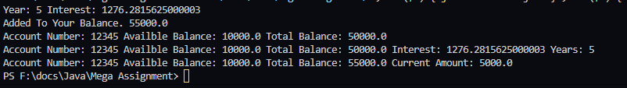

**2. Employees**

Create a class called Employee whose objects are records for an employee. This class will be a derived class of the class [Person](https://www.cs.bham.ac.uk/~mdr/teaching/RedHotChilli/java/Person.java) which you will have to copy into a file of your own and compile. An employee record has an employee's name (inherited from the class Person), an annual salary represented as a single value of type double, a year the employee started work as a single value of type int and a national insurance number, which is a value of type String.

Your class should have a reasonable number of constructors and accessor methods, as well as an equals method. Write another class containing a main method to fully test your class definition.

class Person {

    private String firstName;

    private String lastName;

    public Person(){}   *// default constructor*

*// two argument constructor*

    public Person(String firstName, String lastName){

*this*.firstName = firstName;

*this*.lastName = lastName;

    }

    public void setFirstName(String first) {

        firstName = first; *// should validate*

    } *// end method setFirstName*

*// return first name*

    public String getFirstName() {

*return* firstName;

    } *// end method getFirstName*

*// set last name*

    public void setLastName(String last) {

        lastName = last; *// should validate*

    } *// end method setLastName*

*// return last name*

    public String getLastName() {

*return* lastName;

    } *// end method getLastName*

*// set social security number*

    public String toString(){

*return* "First Name: " + firstName + " Last Name: " + lastName;

    }

}

class Employee extends Person {

    private double anualSalary;

    private int startedYear;

    private String insuranceNumber;

    public Employee(){} *// default constructor*

*// five argument constructor*

    public Employee(String firstName, String lastName, double anualSalary, int startedYear, String insuranceNumber){

*super*(firstName, lastName);

*this*.anualSalary = anualSalary;

*this*.startedYear = startedYear;

*this*.insuranceNumber = insuranceNumber;

    }

    public void setAnualSalary(double anualSalary) {

*this*.anualSalary = anualSalary; *// should validate*

    } *// end method setAnualSalary*

*// return Anual Salary*

    public double getAnualSalary() {

*return* anualSalary;

    } *// end method getAnualSalary*

*// set started year*

    public void setStartedYear(int startedYear) {

*this*.startedYear = startedYear;*// should validate*

    } *// end method setLastName*

*// return Started Year*

    public int getStartedYear() {

*return* startedYear;

    } *// end method getStartedYear*

    public void setInsuranceNumber(String insuranceNumber) {

*this*.insuranceNumber = insuranceNumber;*// should validate*

    } *// end method setInsuranceNumber*

*// return Insurance Number*

    public String getInsuranceNumber() {

*return* insuranceNumber;

    } *// end method getInsuranceNumber*

    public boolean isEqual(Employee e1, Employee e2){

*if* (e1.insuranceNumber.equals(e2.insuranceNumber)){

*return* true;

        }

*return* false;

    }

    public String toString(){

*return* *super*.toString() + " Anual Salary: " + anualSalary + " Started Year: " + startedYear + " Insurance Number: " + insuranceNumber;

    }

}

public class EmployeeMain {

    public static void main(String[] args) {

        Person person1 = *new* Person("Muhammad Tayyab", "Bhutto");

        Person person2 = *new* Person();

        Employee employee1 = *new* Employee("Muhammad Tayyab", "Bhutto", 5000000, 2020, "pk20-0020-2003-3892");

        Employee employee2 = *new* Employee();

        person2.setFirstName("Faheem");

        person2.setLastName("Akhtar");

        employee2.setFirstName("Faheem Akhtar");

        employee2.setLastName("Rajput");

        employee2.setStartedYear(2002);

        employee2.setAnualSalary(20000000);

        employee2.setInsuranceNumber("pk20-0020-2003-4455");

        System.out.println("Person 01 " + person1.toString());

        System.out.println("Person 02 " + person2.toString());

        System.out.println("Employee 01 " + employee1.toString());

        System.out.println("Employee 02 " + employee2.toString());

    }

}



**BEST WISHES**